Session 2: New data possibilities

GIS data in road traffic accident statistics in Finland
To obtain more specific information about the places where road traffic accidents have taken place Statistics Finland has implemented a new geographic information system which gives new geographical information and improves the quality of road traffic accident data. Statistics Finland receives road traffic accident data direct from the Finnish police. At the beginning of 2009, the police started to record accurate co-ordinates for accident scenes. The co-ordinates make it possible to combine road traffic accident data with geographical data.
At the beginning of 2009, Statistics Finland introduced a new geographic information system to help locate the places where road traffic accidents occur. This was done in co-operation with the Finnish police and the Finnish Transport Agency (formerly the Finnish Road Administration).
Combining geographical Digiroad data and road traffic accident data makes it possible to get precise information on the scene of accidents and to improve the quality of the road traffic accident data. Use of the new combined data in the error checking process makes it possible to find potential logical errors concerning an accident.

Geographical Digiroad data
Digiroad is a national road database which contains data on the locations of all roads and streets in Finland as well as on their most important physical features. Digiroad is maintained and updated by the Finnish Transport Agency.
Digiroad includes vehicle accessible roads, ferry and cable ferry connections for cars, railways and separate cycle and pedestrian paths covering a total of 430,000 kilometres. Digiroad contains information on the geometry, physical features and travel related characteristics as well as major service areas and public transport facilities.
The projected co-ordinate system of Digiroad is EUREF-FIN. Geographic co-ordinates are used as storage format for position data. The height system of the Digiroad traffic network is N60.

Combining Digiroad and road traffic accident data
Statistics Finland receives from the police the data on road traffic accidents that are entered into the PATJA information system of police affairs. Local police districts transfer the data to a central register, from which new data are processed and transferred to Statistics Finland’s computer. Using the co-ordinates Statistics Finland combines the road traffic accident information with the Digiroad data.
After entering the data into the database, new accidents are located to the road network with the geographic information system. Figure 1 describes this process. If the co-ordinates are closer than 50 metres from a road, the co-ordinates are located to the nearest road. In case the co-ordinates are not located near the road network they will be corrected in a map application. If the police do not report the co-ordinates it is possible to get the co-ordinates from the street name or address by geocoding. The geocode process includes searching for the address in the reference data and finding the best match, then returning a latitude-longitude co-ordinate on a map.
After locating the accident to the road network the information about the road is transferred to the database. This new information is used in the error checking process.
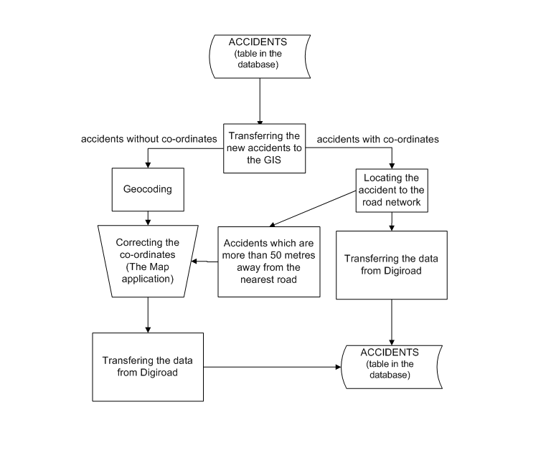
Figure 1

The map application
If the co-ordinates are incorrect it is possible to use a map application to correct them. With the information from the police report one can relocate the accident on a map. In the map application it is also possible to make different inquiries about the roads and their features. One can view the road traffic accident scenes on the map and supplement the data in the database if needed. It is also possible to obtain information about the road type, road illumination, road address and address number, national road class, number of lanes, traffic volume, public transport stops and traffic lights, information whether the accident happened inside or outside a built-up area and if the location is compatible with the accident type.

New information
With the new information from Digiroad Statistics Finland checks the information that the police has reported and supplements the data. For example, if the police do not report the speed limit for the road where the accident happened it is possible to get that information directly from Digiroad. Combining the road traffic accident data with geographical data it is possible to find out, for instance, about the road geometry that is within a set distance of an accident scene that the police might not have reported if there was a bus stop or a resting area nearby, for example.
With the accurate information about the accident scene it is possible to get information about the accident that was not available before. This new information improves the quality of the road traffic accident data. It also gives new possibilities for researchers to use the data in a new way, for example, to locate the most dangerous roads or junctions and also to get some new information about the road features that might have been a partial cause of the accident, such as road geometry. Locating the accidents on a map allows researchers to visualise the data better.

Conclusions
Road traffic accident statistics are used for evaluating the level of road safety. They provide guidelines for road safety measures and traffic planning. A geographic information system allows us to handle, view, understand, interpret and visualise data in many new ways.
For the statistical process the geographic information system improves the quality of the data. With the new geographical information it is possible to supplement the data and also to check the data in a more effective way. It is possible to get some missing information directly from the geographical data so that further inquiries to the police districts are less needed. All in all, the statistical process is more effective and the users have better quality and more information about the road traffic accidents than before.

